**Chapter 4:**

**Introduction to Differential Equations**

**4.3 Separable Equations**

**Section Exercises**

**Solve the following initial-value problems with the initial conditionand graph the solution.**

119. 

Answer:

121. 

Answer:

**Find the general solution to the differential equation.**

123. 

Answer: 

125. 

Answer: 

127. 

Answer:

129. 

Answer:

131. 

Answer:

**Find the solution to the initial-value problem.**

133. 

Answer:

135. 

Answer:

137. 

Answer:

139. 

Answer:

141. 

Answer:

**For the following problems, use a software program or your calculator to generate the directional fields. Solve explicitly and draw solution curves for several initial conditions. Are there some critical initial conditions that change the behavior of the solution?**

143. **[T]**

Answer:

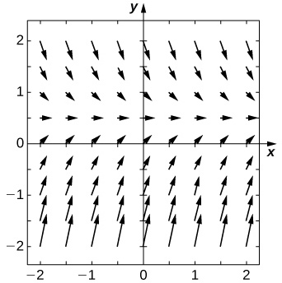

145. **[T]**

Answer:

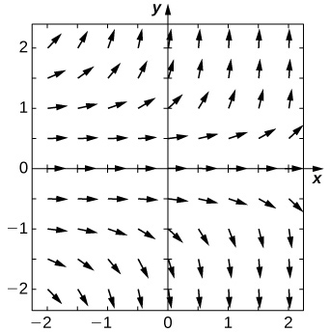

147. **[T]** 

Answer:

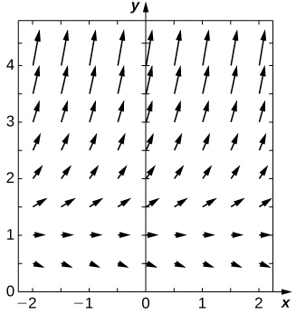

149. A drug is administered intravenously to a patient at a rate mg/h and is cleared from the body at a rate proportional to the amount of drug still present in the body, **Set up and solve the differential equation, assuming there is no drug initially present in the body.

Answer:

151. A tank contains kilogram of salt dissolved in liters of water. A salt solution of  kg salt/L is pumped into the tank at a rate of  L/min and is drained at the same rate. Solve for the salt concentration at time . Assume the tank is well mixed.

Answer:

153. **[T]** For the preceding problem, find how much salt is in the tank  hour after the process begins.

Answer: kilograms

155. For the preceding problem, determine how long it takes the tank to drain.

Answer:seconds

**For the following problems, use Newton’s law of cooling.**

157. **[T]** The liquid base of an ice cream has an initial temperature of  before it is placed in a freezer with a constant temperature of  After  hours, the temperature of the ice-cream base has decreased to  At what time will the ice cream be ready to eat? (Assume  is the optimal eating temperature.)

Answer:hours minutes

159. You have a cup of coffee at temperature  and the ambient temperature in the room is Assuming a cooling rate write and solve the differential equation to describe the temperature of the coffee with respect to time.

Answer:

161. You have a cup of coffee at temperature  and you immediately pour in  part milk to  parts coffee. The milk is initially at temperature  Write and solve the differential equation that governs the temperature of this coffee.

Answer:

163. Solve the generic problem with initial condition 

Answer:

165. Assume an initial nutrient amount of kilograms in a tank with liters. Assume a concentration of kg/L being pumped in at a rate of L/min. The tank is well mixed and is drained at a rate of L/min. Find the equation describing the amount of nutrient in the tank.

Answer:

167. Leaves accumulate on the forest floor at a rate of  g/cm2/yr. These leaves decompose at a rate of  per year. Write a differential equation governing the number of grams of leaf litter per square centimeter of forest floor. Does this amount approach a steady value? What is that value?

Answer:g/cm2

This file is copyright 2016, Rice University. All Rights Reserved.